**GenAI App - AI Code Reviewer**

**Objective**

The objective of this project is to develop a Python application that allows users to submit their Python code for review and receive feedback on potential bugs along with suggestions for fixes. The application should be user-friendly, efficient, and provide accurate bug reports and fixed code snippets.

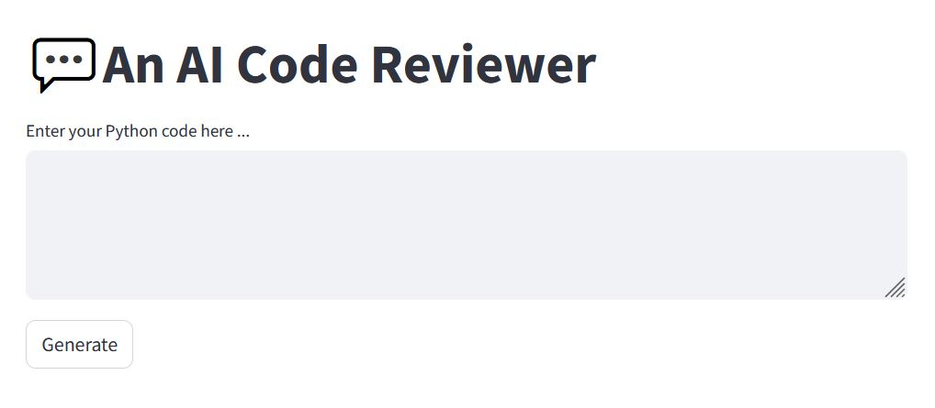

**User Interface**

1. The application should have a clean and intuitive user interface built using **Streamlit**.
2. Users should be able to easily input their Python code into the application.

**Code Review Functionality**

1. Utilize the **OpenAI API** for code review functionality.
2. The application should analyze the submitted code and identify potential bugs, errors, or areas of improvement.
3. The application should also provide the fixed code snippets.

